CORPORATE TECHNOLOGY SERVICES
Monthly Reporting Manual
Xero and Excel · Monthly cycle · Complete series
Monthly reporting turns a month of Xero data into the financial pack the management team reads. This manual covers that cycle end to end, from the first paste out of Xero through to the commentary that goes with the charts.
The three parts are also published as standalone guides. Both are generated from the same source, so they always agree.
How this manual is organised
Part 1 | The P&L Analysis File: raw data, checks, departmental allocation, budget links
Part 2 | The Graphs File: charts, labour hours, full time equivalents, top clients
Part 3 | The Management Report: sales forecast against actual, and the commentary
The order matters. Finish the P&L Analysis file completely before opening the graphs file, and finish the graphs file before writing the commentary. Each stage feeds the next, so going back to correct an earlier one means redoing the work that followed it.
Everything here was recorded live in Video 7, Day 5 tasks - Reporting Graphs and HOD Meeting preps. Where the recording shows something being worked out or corrected on camera, this manual says so rather than presenting it as settled.
Several steps are still done by hand: the legal fees split, the budget column links, the labour hours, the client name matching and the sales forecast. Those are marked clearly, because they are where the mistakes happen and they are the first candidates for automation.
Contents
If this page looks empty, Word has not yet built it. Right-click anywhere on it and choose Update Field, or answer Yes when Word offers to update fields on opening.

Part 1: The P&L Analysis File
Corporate Technology Services · Xero and Excel · Monthly cycle

About Part 1
Monthly reporting runs on two spreadsheets. This guide covers the first of them, the P&L Analysis file. It is where the raw data from Xero lands, where overheads get allocated across departments, and where every check lives.
Part 2 covers the graphs file. Part 3 covers the management report and the commentary.
Finish this file before you open the graphs file. Do all the checks, all the reclassifications, and any corrections in Xero first. Only when you are happy with every figure here do you copy anything into the graphs file. Working the other way round means handling everything twice.

What is in the file
The tabs fall into three groups: raw data you paste in, checks that tell you whether the paste worked, and allocation tabs that split overheads across departments.
GL code database | Every account we have. Fixed. Nothing to maintain, not even at a new financial year.
Xero P&L | A paste of the profit and loss report out of Xero
GL transactions | A paste of the detailed account transactions report out of Xero
Revenue Summary | The pivot that feeds the top clients pie chart
2. CTS PL | Reconciliation check against the P&L
3. CTS PL - No OI | The same check without other income and interest expense
4. PL Per Department | The month, allocated by department
5. PL Per Department Excl OI | The month, allocated, excluding other income. This is the reporting one.
6. YTD PL Per Department | Year to date, allocated
7. YTD PL Per Dept Excl OI | Year to date, excluding other income
8. Qtrly PL Per Dept - No OI | The quarter, excluding other income

Step 1 Paste the Xero P&L
Run the profit and loss report in Xero for the months you need, download it, and paste it into the Xero P&L tab.
Re-paste every prior month, not just the new one. Do not feed the new month off the previous month's figures. Paste the whole year to date again each time. Earlier months can move: an Aware Super adjustment retrospectively changed a July figure, and anyone working off the old paste would never have seen it.

So in August you paste July and August. In September you paste July, August and September, and so on.
The row headings down the side should already match what is in the tab, but check them anyway in case an account has been added or renamed.
The rule the team works to. If something needs changing, it goes into the current month with a note, rather than being adjusted backwards. Prior months should not normally move. When one does, it is worth knowing why.

Step 2 Run and paste the GL transactions
This tab is the detailed version of the P&L, one row per transaction. It comes from a saved custom report in Xero called Account transactions for P&L analysis.
To find it, go to All Reports and then Custom. It is worth favouriting it, along with the profit and loss report, so you are not hunting for it every month.
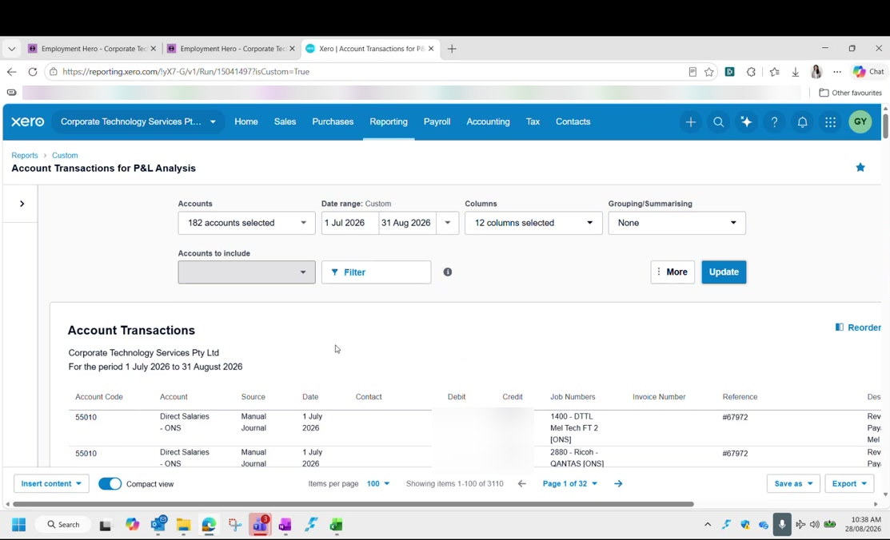
Figure 1: The Account Transactions for P&L Analysis report in Xero, favourited, run from 1 July. Transaction amounts are blurred in this guide.
Date range | Year to date, from 1 July. Every month, not just the new month.
Sort by | Account code. It comes out in random order otherwise.
Order you want | 4 for revenue, then 5 for cost of sales, then 6 for overheads

Download it. It comes out looking almost exactly like the spreadsheet tab, so it is mostly a straight copy and paste.
Convert to number first. The download carries a warning marker on the values. Convert the column to number before pasting, or the totals will not add up.

When pasting, take the source columns across to the matching columns up to L in the tab. Leave out two things:
- The index column, which is a different shade of blue
- The columns further right that contain formulas

Step 3 Fix the Stripe fee rows
After pasting you will see gaps, mostly near the bottom, where rows have no department and no cost centre. These are the Stripe fees.
It happens because Xero splits a card payment three ways: credit card income, credit card expense, and the payment itself. The credit card expense never gets a cost centre.
Department | Admin
Cost centre | CTS

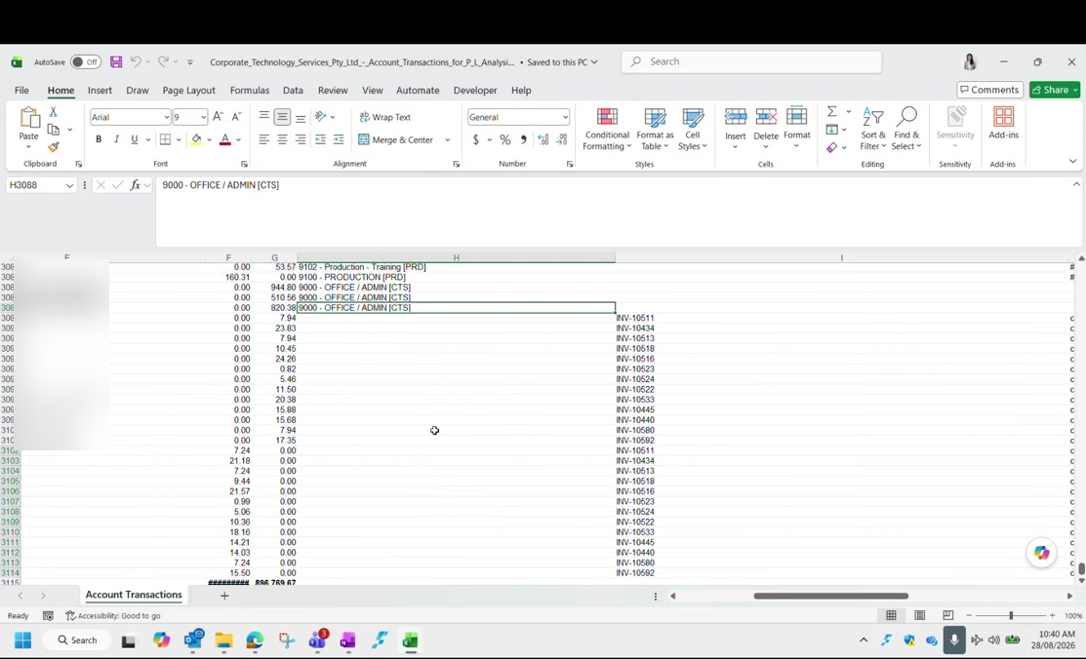
Figure 2: Filling the department column down to 9000 - OFFICE / ADMIN [CTS] across the fee rows in the raw data file. Contact names are blurred in this guide.
Do not try to allocate these properly. In principle each fee belongs to whichever department earned the income. In practice the amounts are cents to a few dollars, and working out which is which takes far longer than it is worth. Set them all to Admin and CTS and move on. The fees then get split three ways with everything else in Admin.

Step 4 Fill in the missing contacts
The top clients pie chart is built from the Contact column. When an invoice is raised in Xero the contact comes through automatically, but a manual journal has no contact at all, so those rows arrive blank.
Filter to the manual journals and type the contacts in. The description on the row will usually tell you who it is for. Xero often autocompletes once you start typing.
Revenue only. You only need contacts on the revenue rows, the 4 codes. Once the codes start with 5 you are into cost of sales, and top clients are only tracked for revenue.

Every client must be spelled one way. This feeds a pivot table, so one client has to be one name. All the Commonwealth Bank variants become Commonwealth Bank of Australia, not separate rows for Brisbane, Melbourne and the rest. If you leave them split, the pie chart shows the same client several times and understates them all.

Do this editing in the raw data file before you paste, rather than in the analysis file. That way the analysis file only ever receives clean data.

Step 5 Refresh the Revenue Summary pivot
The Revenue Summary tab holds a pivot table built off the GL transactions. It is set up with contact and amount, and filters for account type, year, quarter and cost centre.
Account type filter | Income, so cost of sales is excluded
Quarter filter | Set to the quarter you are reporting
Cost centre filter | Used when you want a single department rather than the whole company

Ignore the stray Q3 rows. The quarter formula is dragged to the bottom of the column, and blank rows below the data default to Q3. If you are working in Q1 the Q1 figures are still correct. It is untidy, not wrong.

Step 6 Read the reconciliation checks
Tabs 2 and 3 reconcile the detailed data dump back to the P&L. If they say TRUE, the paste worked and there is nothing to do.
Tab 2 | Reconciles the data dump against the P&L, including other income and interest expense
Tab 3 | The same reconciliation with interest received and interest expense stripped out

If tab 2 balances you can assume tab 3 does too. The only difference between them is the interest lines.
A FALSE is usually rounding. Check the reference is pointing at the right cell first. If the cell reference is right and the difference is tiny, it is a rounding artefact: a figure carrying seventeen decimal places. Round it and the check turns TRUE. This happens now and again for no obvious reason.

Step 7 Update the allocation tabs
Tabs 4 to 8 are where overheads get pushed out across the departments. They cover three periods:
Tabs 4 and 5 | The month. You must change the date on these two so the data pulls for the right month.
Tabs 6 and 7 | Year to date. Nothing to change; they capture everything automatically.
Tab 8 | The quarter. Toggle it between Q1 and Q4.

Within each period there are two versions:
- Per department including other income and other expense
- Per department excluding other income and other expense
The excluding version is the one that matters. The tabs that exclude other income are what goes into the graphs file and into the report. They are highlighted in a different colour so you can pick them out. Every graph should reference those, not the including version.

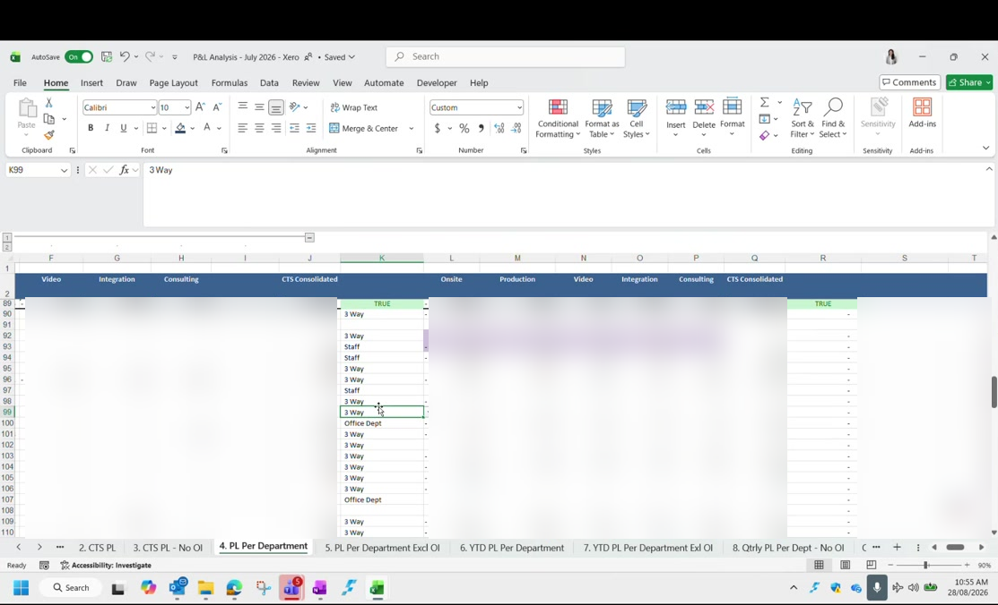
Figure 3: The allocation tabs, with the split basis against each row and the TRUE checks at the top. Figures are blurred in this guide.
The date cells you have to change each month are highlighted too. If the check on the tab already says TRUE, there is nothing more to do.

How the allocation actually works
The left of each allocation tab is raw data. The right is where it gets allocated out. Anything sitting in Admin is split across the departments using preset percentages, pulled in with an XLOOKUP.
There is not one split. There are three, and each overhead row is labelled with the one that applies to it. You can see the label against every row on the allocation tab.
3 Way | Split roughly evenly three ways, near enough a third each
Staff | Split by headcount, so it follows where the people actually are
Office Dept | Weighted heavily to one department, for costs that mostly belong there

The percentages themselves live in the budget file, set against three groups: production and video, onsite, and consulting and integration.
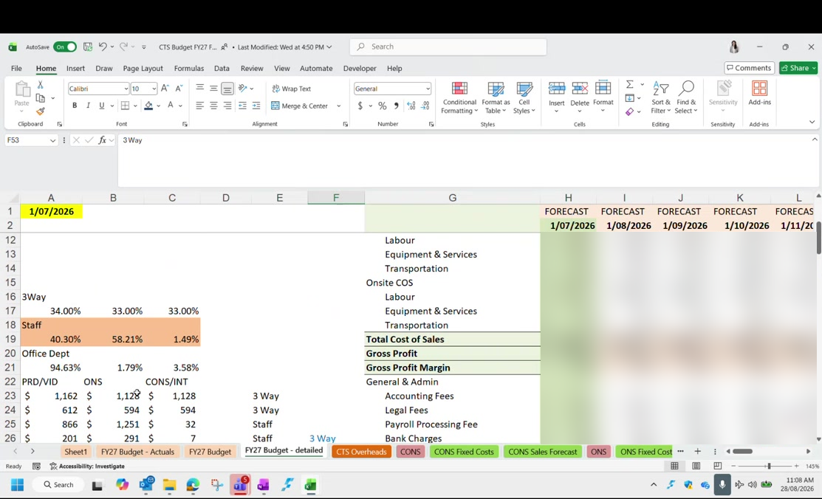
Figure 4: The three split bases and their percentages in the budget file, with the forecast columns running across. Budget figures are blurred in this guide.
So a payroll processing fee sitting in Admin is divided out according to whichever of the three bases its row is labelled with.
The staff split follows headcount, and consulting is nearly empty. On the staff basis, consulting and integration together carry only a fraction of the overhead, because almost nobody is employed there. The day someone is hired into consulting, that percentage has to be changed by hand. Nothing will prompt you, and until it is changed consulting will carry almost none of the overhead it should.

Do not change the split mid-year. If management wants to revisit the overhead split, that is a decision for the management team, and it should take effect at a new financial year. Changing it in December means the six months already reported were built on a different split and no longer compare. Be firm about this when it comes up, because it will.

The split only exists inside these spreadsheets. Nothing needs changing in Xero to match it.

Step 8 Add the legal fees split by hand
There is one GL code for legal fees, but the report separates it in two, so this part is manual every month.
Eastern Bell | The actual lawyers. Whatever has been spent, if anything.
Employsure | Fixed at $800 a month on a contract, and always there

The Employsure amount is a locked-in retainer, so it appears in Xero under repeating bills. The bill counter there tells you how many are left to come.
The figure is cumulative, and this is easy to get wrong. On the month tab you enter $800. On the year to date tab you enter the running total, so $1,600 after two months. On the quarter tab you enter $2,400 for three months. Enter $800 on the year to date tab by mistake and the tab goes out of balance.

If you forget it entirely, the check on that tab turns FALSE. Put the amount in and it turns TRUE again. The same trigger exists on every tab, so a mistake here does get caught.
Any other legal spend is populated by hand against whichever department it belongs to. Duncan will normally advise where it should be coded.

Step 9 Re-point the budget links
The budget figures live in a separate file, Budgets and Forecast FY27. The analysis file reads a column out of it, and that column has to be moved along by one every month.
Hard code the previous month first. Changing the formula changes the earlier month too, because they share the reference. Hard code last month's figures before you re-point anything, or you will lose them.

Then move the reference along one column. Going from July to August, that is H to I on the main tab. The departmental tabs each sit one column apart:
Onsite | F becomes G
Consulting | G becomes H
Production | H becomes I

Leave the grey cells alone. The grey cells are totals. Change every reference except those.

You know you have done it correctly when the check cell reads zero. If it is out, one reference has been missed.
The budget must be split the same way as the actuals. The budget P&L is split across departments using exactly the same percentages as the actual P&L. If you change the staff split because someone has been hired into consulting, you have to change it in the budget file as well, or the two will never reconcile.

The budget file is worked on in place, month after month, rather than copied fresh each month. Earlier months are preserved because they have been hard coded, and the departmental tabs stay linked.

When a check will not balance
A small variance is harder to find than a large one, because a large one tells you roughly where to look. This is worth knowing before it happens to you.
Work it in this order:
- Check every reference you just changed actually points at the new column
- Add up the overhead categories in blocks and tick off the ones that agree, to narrow down where the difference lives
- If the main tab agrees, the variance is in a departmental tab
- In a departmental tab, look for anything picked up from two places at once
The trap is double counting a departmental overhead. Some costs are coded straight to one department, production insurance for example. A departmental tab should take the share of the overhead split plus that department's own overhead. If instead it references the previous cell, which already includes the same amount, the cost lands twice. This was found on camera and fixed by pointing the formula at the split plus the departmental figure, and locking the row reference so it does not drift when dragged.

Checklist
The P&L Analysis file is finished when:
- The Xero P&L tab holds every month of the year to date, freshly pasted
- The GL transactions tab holds the custom report, run from 1 July and sorted by account code
- Values were converted to number before pasting
- Every Stripe fee row is set to Admin and CTS
- Every revenue row has a contact, and each client is spelled one consistent way
- The Revenue Summary pivot has been refreshed
- Tabs 2 and 3 read TRUE
- The month has been changed on tabs 4 and 5, and the quarter on tab 8
- The Employsure amount is in, cumulative on the year to date and quarter tabs
- Last month's budget figures were hard coded before the links moved
- Every budget reference moved on one column, grey cells excepted, and the check reads zero

Continues in: Part 2: The Graphs File.

Part 2: The Graphs File
Corporate Technology Services · Excel · Monthly cycle

About Part 2
Once the P&L Analysis file balances, the graphs file is where the numbers become charts. Most of it is already linked, so the work is smaller than it looks. What it needs is a handful of pastes, a few relinks, and three things that are still worked out by hand.
It is a data dump, and it looks like one. The file holds data going back to 2021 and graphs that nobody uses any more. That is deliberate. They were left there by the people who built it, because Duncan occasionally asks for a chart to be reproduced and it is easier to find one than rebuild it. Do not tidy it up.

Step 1 Paste in the three departmental tabs
From the P&L Analysis file, take the per department tabs that exclude other income, the ones highlighted in a different colour, and paste them here.
- The month
- The year to date
- The quarter
The front page chart, the one that opens the financial presentation, flows through from the month automatically. Around ninety per cent of everything else in the file is linked to these three pastes.

Step 2 Fill in the employment expenses
One cell is grey rather than linked: employment expenses. It is split two ways, and the split is the point of it.
Departmental staff | The employment cost that genuinely belongs to that department
Office staff | Admin salaries pushed into that department, either by the overhead split or because someone clocked into one of its cost centres

The reason for separating them is to see what a department actually costs to run without admin loaded on top. Someone in the management team who works across support, production and consulting will have their salary divided between the three by their timesheets, but they are not part of any of those departments. Their cost belongs in office staff.
This split is only about a year old. It was introduced recently, so there is less history behind it than the rest of the file. If a figure looks odd, that is worth remembering.

Step 3 Update the labour hours
One section changes every month and is driven by labour hours, which come straight from the utilisation report.
The utilisation data is kept as a separate saved file, because running the full report is slow. It gives you, per department, the number of staff, the cost centres across the top, and hours split between chargeable and non-chargeable.
Filter it to a rolling twelve months. Not the month, and not the financial year to date. For a July report you run September through to August of the previous twelve. The whole point is the rolling picture.

The file is split by department, and each department has a second tab beside it called Other CC: onsite and onsite Other CC, consulting and consulting Other CC, production and production Other CC. Other CC holds hours a person worked on a cost centre that is not their default one. Someone based in support who picks up consulting work will have those hours land there, and only those hours, not their whole timesheet.
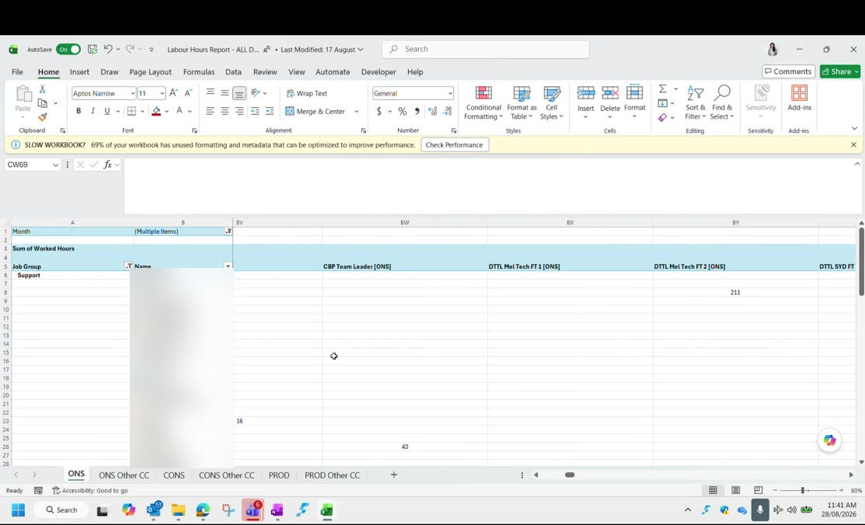
Figure 5: The labour hours report, showing the department tabs and their matching Other CC tabs. Employee names are blurred in this guide.

Working out full time equivalents
For each department, add the department's own total hours to its Other CC hours, then divide by the total working hours in a year.
Numerator | Department total hours plus Other CC hours
Denominator | Total working hours in a rolling year
Where the denominator comes from | The Days tab in the utilisation report file: working days for the rolling twelve months, multiplied by eight

Check this number rather than assuming it. The answer should land on either 2,080 or 2,088 hours. The Days tab is also split by state, and it has to be kept up to date as the months roll on, so it is easy to read the wrong row and get a figure that is neither. If your working comes out at something else, go back to the Days tab before you use it.

Sense check the result against what you know. Consulting shows almost no full time equivalent in the P&L because the person doing consulting work is a casual engaged ad hoc rather than employed in that department. Production has six full timers but comes out around eight, because of the casuals it engages, and that number moves with how busy they are.
The figure barely moves. Month to month the full time equivalent changes by a fraction of a decimal place. If you see it move materially, something is wrong with the hours rather than with the business. When the profitability per employee figure moves, it is almost always the profit that changed, not the headcount.

Step 4 Profitability per employee
This is profit divided by the full time equivalent headcount you just worked out. It gives a figure such as nineteen and a half employees each generating a certain profit.
It is not really per employee. There is no true profitability per employee in this report. It is a departmental profit spread across a calculated headcount. It is a recent idea and the person who built it has said openly that a better method would be welcome. Do not present it as more precise than it is.

Step 5 The gross margin scenario chart
One chart asks a hypothetical question: what would the gross profit margin be if departmental employment expenses were treated as cost of sales instead of overhead?
The non chargeable employment cost sitting at the bottom gets moved up into labour, and the margin drops. A gross profit of around forty four per cent might become around forty.
What it is showing. It is the margin the business would report if every team were fully utilised, which never actually happens. It is a reference point, not a target.

Step 6 The quarterly charts
The quarterly section pulls automatically from the quarter tab. The work is changing the labels and the ranges, and one thing that is easy to forget.
- Change the quarter label, for example Q4 to July through September
- Update the matching ranges, which follow the same pattern
- Relink each quarter one at a time; there is no shortcut here
Hard code a quarter as soon as it is finished. Before you paste the next quarter's data, hard code the one before it. Otherwise the earlier data moves and you will have to redo it. Leave a note on the tab saying it has been updated, meaning hard coded, because it is easy to forget which quarters are safe.

If a quarter's profit figure suddenly looks wrong, check whether you are looking at the previous quarter's data that never got hard coded.
Multi-quarter charts wait until Q2. The charts that compare several quarters are not worth showing in Q1, because the single quarter is already on the page above. They start being useful from Q2 onwards.

Step 7 The revenue tabs
The older revenue tab is no longer used and does not need updating. On the tab that is used, only the actuals need touching, and they are marked in green so you can find them.
The figures are lump sums per department rather than a full breakdown. Production, video, consulting and integration are not separated here; consulting is one number and production is one number.
You can link the cells to the P&L Analysis file rather than typing them, but hard code them once the month is done, because the link will otherwise move when you point it at the next month.
Name the file consistently. If you link to the P&L Analysis file, keep its name in the same format every month. Change the naming and every link has to be repaired.

Step 8 The running total chart
One chart compares actual against budget as a running total across the year. Each month you add the new month's figures to the total so far.
It has to be a running total. If you enter the month on its own the line goes up and down instead of climbing, and it looks wrong immediately. The budget side is already set for the year, so the only thing you update is the actual.

It looks odd when you are only two months into the year. That is expected, and it improves as the months build up.

Step 9 The top clients charts
This is the pivot work from Part 1 arriving in the graphs file, and it has a definite order.
- Clear the previous month's contents
- Paste in the new data from the Revenue Summary pivot
- Refresh the pivot table here
- Update the ranking column and drag it down
The ranking is what sorts the chart, and it feeds through automatically because there is an XLOOKUP on either side of it.
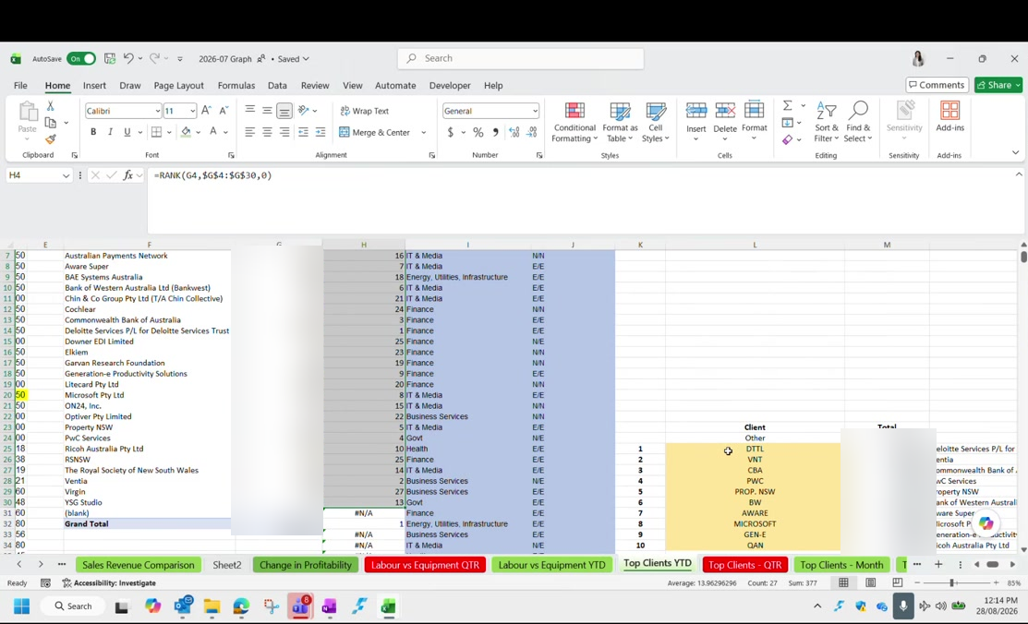
Figure 6: The top clients tab: the RANK formula on the left, and the yellow block where the pulled name is matched to the display name. Revenue figures are blurred in this guide.
The yellow cells are the manual bit. The name the pivot pulls through has to be matched to the display name shown on the chart. Those are the yellow cells. The display names are stock exchange listing names rather than trading names, which is why they look abbreviated. Where you do not know one, typing the ordinary company name is what has been done before and is perfectly acceptable.

Do the same for the quarter, using quarter data, and for the month if you need it. Year to date, quarter and month each have their own place to paste.
Industry and engagement type come from an older file. The revenue by segment chart and the engagement type chart in the quarterly report need each client tagged by industry and by type of engagement. That mapping lives in the previous financial year's June file, on a client tab. It is partly out of date, so check anything that looks wrong before reusing it.

Finally, repeat the whole top clients exercise per department: once for onsite, once for production, once for consulting.

Charts you can skip
Several charts in the file are no longer used, and the unused ones have red tab colours so you can spot them. Knowing which to skip saves a lot of time.
Sales Revenue Comparison | Used. Actuals only, marked green.
The older revenue tab | Not used at all
Change in Profitability | Half year and full year only. Marked red because it is usually skipped.
Labour vs Equipment QTR | Marked red. Use the year to date version instead; the mix barely moves.
Labour vs Equipment YTD | This is the one to use
Top Clients YTD, QTR and Month | All three exist. Year to date is always needed; the others depend on the report.
Onsite revenue versus profitability | Built when that department was running at a loss. Not relevant while it is profitable.
Expenses trend | Full financial year only

The recurring revenue chart. On the labour and equipment pie, the darker the colour the more recurring the revenue: fixed fee support contracts and repeating licence fees. Because it barely moves, the year to date version is the one to use, and the quarterly one is marked so you know to leave it.

Checklist
The graphs file is ready when:
- The month, year to date and quarter tabs excluding other income have been pasted in
- Employment expenses are split between departmental staff and office staff
- Labour hours have been taken from the utilisation report on a rolling twelve months
- Full time equivalents were calculated against 2,080 or 2,088 hours, checked on the Days tab
- The previous quarter is hard coded before the new quarter is pasted
- The running total chart has this month added to the total so far
- The top clients pivots are refreshed, ranked, and the yellow name cells matched
- Top clients has been repeated for onsite, production and consulting

Continues in: Part 3: The Management Report.

Part 3: The Management Report
Corporate Technology Services · Commentary and sales forecast · Monthly cycle

About Part 3
The charts are built. What remains is the part that carries the judgement: comparing actual revenue against what each department said it would do, and writing the commentary that goes with it.
This is the most manual stage of the month, and the one where knowing what normal looks like matters more than knowing where the buttons are.

Step 1 Update the sales forecast against actual
Each department has a sales forecast that was set as their budget. Every month you go in and record what actually happened next to it.
- Unhide the columns so you can see the month you are working on
- Change that month's label from budget to actual
- Enter the achieved figures, client by client
- Highlight what you have entered manually, in the colour already used, so the next person can see it was typed rather than calculated
Close is good enough. It does not have to reconcile to the cent. Work in progress revenue forms part of the P&L but is not invoiced to a client, so an exact tie back is not possible. Being close is the standard here.

Department by department
Each department is populated differently, and they get harder in this order.
Onsite | Budgeted per role, not per client. A line such as a team leader position is that person's revenue charged to the client.
Consulting | Straightforward. Usually a short list, and you already know from the revenue meeting which clients are in it.
Production | The hardest. Production and video are separate, so it takes the longest. Leave it until last.

For onsite, where several roles are billed inside a single invoice, open that invoice in Xero and check whether there was a deduction against the role before you record it.
For production, any client with revenue who is not already listed goes into the new business lines. Rather than adding a row per client, everything unlisted is grouped into one line.
Why the revenue tracker cannot just be linked. The tracker records revenue per client. The onsite budget records it per role, so the two do not line up. On top of that, one client can run several events in a month, and each has to be added to the tracker by hand anyway. Linking it would not remove the manual work, only move it.

Check work in progress for the licence clients. Some consulting revenue comes from licences rather than invoices, and it usually stays the same each month. Confirm the amount against the work in progress tracker rather than assuming last month's figure still holds.

Step 2 Write the commentary
The commentary explains the variance rather than restating it. Much of it you will already know, because you have just spent the morning reconciling the revenue.
You can use AI to draft it from the report, and that is a reasonable shortcut, but two cautions apply.
- Explain what kind of business this is first, or the analysis will be generic
- Filter what comes back; use what is actually true and leave the rest
One change management has asked for. For consulting, where revenue did not come in, say whether the deal was lost or simply moved to a later month. You will not know which, so ask Jordan. A message is enough; the revenue meeting is too late in the cycle for it to help.

Compare dollars, not percentages. Where you are comparing against last year, management prefer dollar value against dollar value. Percentages read as more precise than they are.

What normal looks like
This is the part that is hardest to pick up from a spreadsheet, and it is what tells you whether a number is worth a comment.
Support and managed services | Always profitable. Gross margin sits around 45 per cent, net profit above 10 per cent.
Production | Very seasonal. Gross margin should be 55 per cent or better; in the 40s is worth investigating, usually equipment or labour.
Integration | Gross margin should be at least 15 per cent. Net profit is skewed by how few people work in it.
Consulting | Frequently below budget. A loss in most months is normal, not a red flag.

The production calendar is worth learning, because it explains most of what you will see:
August and September | Results season. Should be profitable; if not, that is worth a comment.
October to December | The peak, driven by annual general meeting season. Their most profitable quarter.
December and January | Quiet
February | Picks up again
March | Quiet
May and June | The peak for integration and consulting, as the financial year closes

A department beating budget is not always good news about the budget. One department came in well above budget because they had understated what was in their pipeline. If actuals run consistently far above budget, that is worth raising, because the budget is what everything else is measured against.

The other commentary sections
A few charts each want a particular kind of note against them.
Operating costs | Highlight anything unusual for the month: a company event, a one off IT purchase. They want the outliers called out.
Overheads breakdown | Rent and IT both rose against last year, so those two are being tracked for consistency.
Top clients | Four headings every time: revenue increased, revenue decreased, new to the list, dropped off the list. Always against last year.
Support engagement mix | The percentage of revenue direct to client against subcontracted. The direct clients have been stable for some time.

Step 3 The utilisation section
The monthly utilisation view does not tell you much, so it goes in the report but gets passed over quickly. The rolling twelve months is what the meeting looks at.
Negative figures mean someone is under their target: chargeable time in the mid forties against a target of around sixty five. That is genuinely under target, not a reporting artefact.
Read a small negative before flagging it. For a team whose hours are almost all chargeable, a small negative usually just means they took leave that month. A sustained gap is the one worth raising.

Watch for people changing department. When someone moves permanently from one department to another, they should drop off the old department's list because it is a pivot table. Check that they actually have. If they are still showing in the old team, remove them.

Step 4 Show budget alongside actual
Management have asked for a change going forward. Rather than hiding the budget column once the actual is in, show both.
So for an August report they want July actual, August actual, and August budget side by side.
This is manual. In the budget file, copy the column across, label it with the month, and type the figures in from the P&L. Then update the year to date tab to include it. Repeat every month.

You can show it as budget against actual, or as budget against last year. Showing all three at once is a lot of numbers on one page, so it is a judgement call.

Checklist
The management report is ready when:
- Every department's forecast tab shows the month as actual, with the figures entered and highlighted
- Onsite roles have been checked against the underlying invoices for deductions
- Unlisted new clients have been grouped into the new business line
- Licence based consulting revenue has been confirmed against work in progress
- Missing consulting revenue is marked as lost or deferred, confirmed with Jordan
- Unusual operating costs are called out
- Top clients carries all four headings against last year
- Margins have been sense checked against what normal looks like for each department
- Anyone who has changed department has dropped off their old utilisation list
- The budget column is shown alongside the actual, not hidden

Continues in: This completes the monthly reporting cycle. The next month begins again at Part 1: The P&L Analysis File.

